Федеральное государственное образовательное бюджетное

учреждение высшего образования

**«Финансовый университет при Правительстве Российской Федерации»**

**(Финансовый университет)**

Колледж информатики и программирования

**ОТЧЁТ**

**По лабораторной работе №3**

Студент: Гордов Максим Олегович

Дисциплина/Профессиональный модуль: Разработка программных модулей

Группы: 4ИСИП-619

Преподаватель

Сибирев И.В.

Оценка за работу :_______

**Москва – 2022 г.**

**Задание**

1 Изучить синтаксис команд CREATE (ALTER, DROP) DATABASE,

CREATE (ALTER, DROP) TABLE, ADD (DROP) CONSTRAINT

Выпалнено

2 Создать базу данных из лабораторной работы №1. Создать таблицы, ключи и связи. Реализовать задание средствами

а) SQL Server Management Studio с помощью графического интерфейса;

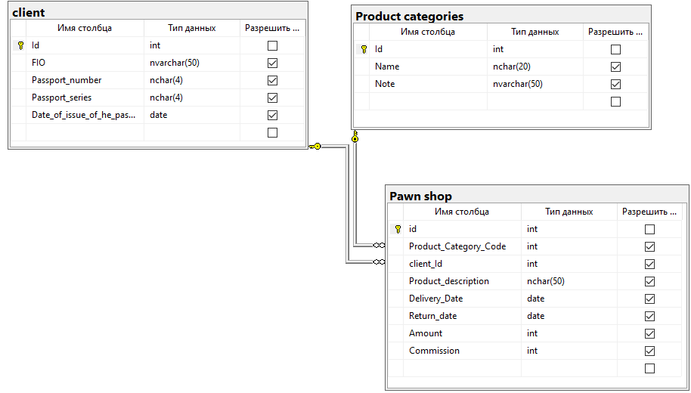

б) с помощью Transact - SQL запросов;

код

CREATE TABLE [dbo].[client](

[Id] [int] NOT NULL,

[FIO] [nvarchar](50) NULL,

[Passport_number] [nchar](4) NULL,

[Passport_series] [nchar](4) NULL,

[Date_of_issue_of_he_passport] [date] NULL,

CONSTRAINT [PK_client] PRIMARY KEY CLUSTERED

(

[Id] ASC

)WITH (PAD_INDEX = OFF, STATISTICS_NORECOMPUTE = OFF, IGNORE_DUP_KEY = OFF, ALLOW_ROW_LOCKS = ON, ALLOW_PAGE_LOCKS = ON, OPTIMIZE_FOR_SEQUENTIAL_KEY = OFF) ON [PRIMARY]

) ON [PRIMARY]

GO

/****** Object: Table [dbo].[Pawn shop] Script Date: 09.11.2022 13:54:47 ******/

SET ANSI_NULLS ON

GO

SET QUOTED_IDENTIFIER ON

GO

CREATE TABLE [dbo].[Pawn shop](

[id] [int] NOT NULL,

[Product_Category_Code] [int] NULL,

[client_Id] [int] NULL,

[Product_description] [nchar](50) NULL,

[Delivery_Date] [date] NULL,

[Return_date] [date] NULL,

[Amount] [int] NULL,

[Commission] [int] NULL,

CONSTRAINT [PK_Pawn shop] PRIMARY KEY CLUSTERED

(

[id] ASC

)WITH (PAD_INDEX = OFF, STATISTICS_NORECOMPUTE = OFF, IGNORE_DUP_KEY = OFF, ALLOW_ROW_LOCKS = ON, ALLOW_PAGE_LOCKS = ON, OPTIMIZE_FOR_SEQUENTIAL_KEY = OFF) ON [PRIMARY]

) ON [PRIMARY]

GO

/****** Object: Table [dbo].[Product categories] Script Date: 09.11.2022 13:54:47 ******/

SET ANSI_NULLS ON

GO

SET QUOTED_IDENTIFIER ON

GO

CREATE TABLE [dbo].[Product categories](

[Id] [int] NOT NULL,

[Name] [nchar](20) NULL,

[Note] [nvarchar](50) NULL,

CONSTRAINT [PK_Product categories] PRIMARY KEY CLUSTERED

(

[Id] ASC

)WITH (PAD_INDEX = OFF, STATISTICS_NORECOMPUTE = OFF, IGNORE_DUP_KEY = OFF, ALLOW_ROW_LOCKS = ON, ALLOW_PAGE_LOCKS = ON, OPTIMIZE_FOR_SEQUENTIAL_KEY = OFF) ON [PRIMARY]

) ON [PRIMARY]

GO

ALTER TABLE [dbo].[Pawn shop] WITH CHECK ADD CONSTRAINT [FK_Pawn shop_client] FOREIGN KEY([client_Id])

REFERENCES [dbo].[client] ([Id])

GO

ALTER TABLE [dbo].[Pawn shop] CHECK CONSTRAINT [FK_Pawn shop_client]

GO

ALTER TABLE [dbo].[Pawn shop] WITH CHECK ADD CONSTRAINT [FK_Pawn shop_Product categories] FOREIGN KEY([Product_Category_Code])

REFERENCES [dbo].[Product categories] ([Id])

GO

ALTER TABLE [dbo].[Pawn shop] CHECK CONSTRAINT [FK_Pawn shop_Product categories]

GO

USE [master]

GO

ALTER DATABASE [LAb] SET READ_WRITE

GO

